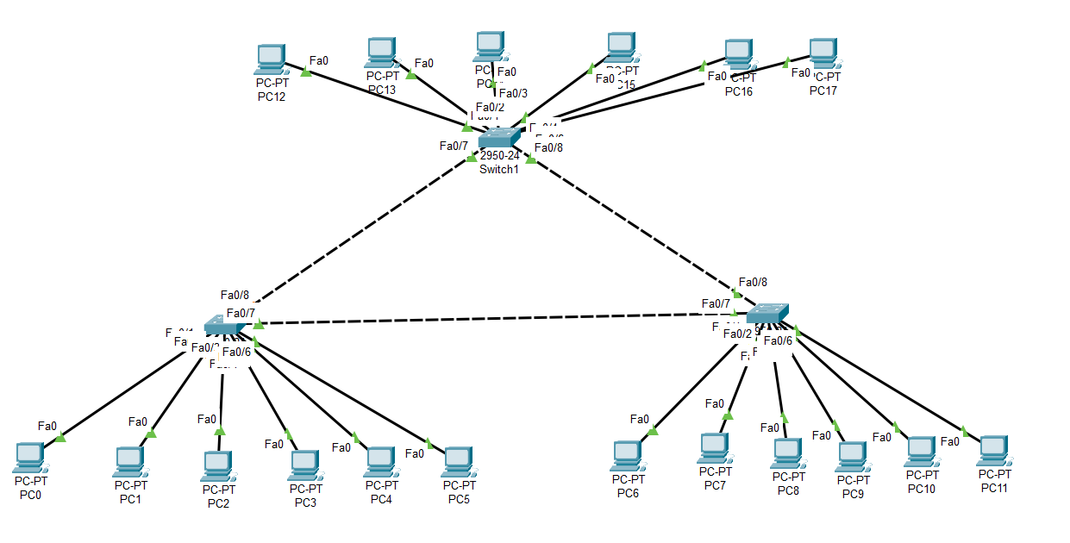

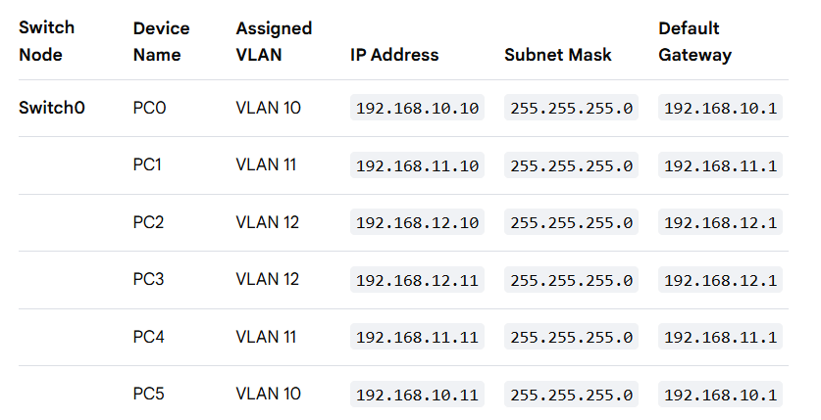
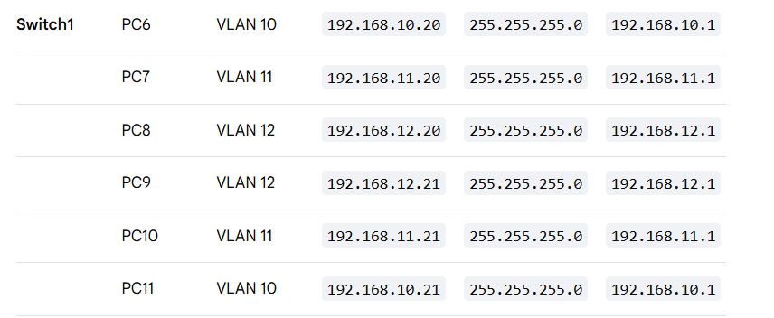
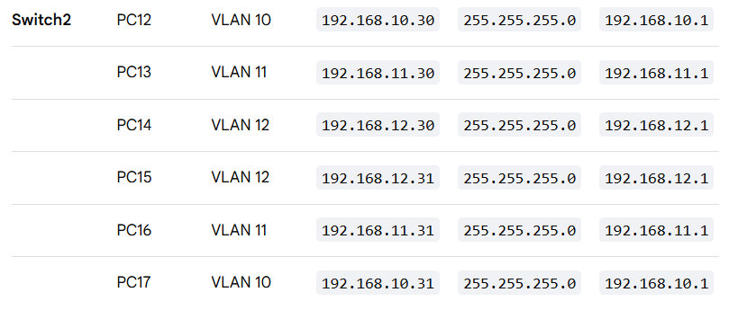

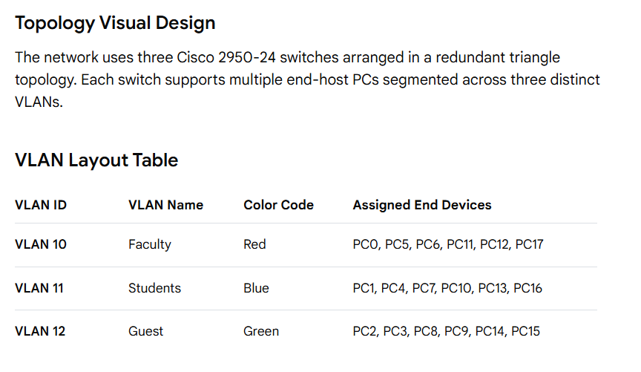
3. Configuration Commands (Cisco CLI)
Step 1: Initialize Database and Create VLANs
Execute these commands on Switch0, Switch1, and Switch2:
text
Switch> enable
Switch# configure terminal
Switch(config)# vlan 10
Switch(config-vlan)# name Faculty
Switch(config-vlan)# exit
Switch(config)# vlan 11
Switch(config-vlan)# name Students
Switch(config-vlan)# exit
Switch(config)# vlan 12
Switch(config-vlan)# name Guest
Switch(config-vlan)# exit
Step 2: Configure Access Ports for End Devices
Assign the physical switch interfaces to their designated logical networks.
On Switch0:
text
Switch0(config)# interface range fa0/1-2
Switch0(config-if-range)# switchport mode access
Switch0(config-if-range)# switchport access vlan 10
Switch0(config-if-range)# exit

Switch0(config)# interface range fa0/3-4
Switch0(config-if-range)# switchport mode access
Switch0(config-if-range)# switchport access vlan 11
Switch0(config-if-range)# exit

Switch0(config)# interface range fa0/5-6
Switch0(config-if-range)# switchport mode access
Switch0(config-if-range)# switchport access vlan 12
Switch0(config-if-range)# exit
(Repeat corresponding range mappings on Switch1 and Switch2 based on your specific topology layout port-bindings).
Step 3: Configure Trunk Links Between Switches
Inter-switch connections must carry traffic for all three VLANs simultaneously.
On Switch0 (Interfaces connecting to Switch1 and Switch2):
text
Switch0(config)# interface range fa0/23-24
Switch0(config-if-range)# switchport mode trunk
Switch0(config-if-range)# switchport trunk allowed vlan 10,11,12
Switch0(config-if-range)# no shutdown
(Apply identical trunk commands on the corresponding interconnecting interfaces of Switch1 and Switch2).

4. Verification and Testing
VLAN Database Verification
To ensure VLANs are correctly created and mapped to physical ports, execute:
text
Switch# show vlan brief
- Expected Output: VLAN 10, 11, and 12 must display an status of active alongside their assigned FastEthernet ports.
Trunking Link Verification
To verify operational inter-switch trunk links, execute:
text
Switch# show interfaces trunk
- Expected Output: The interconnected ports should list their mode as on, status as trunking, and native VLAN as 1.
ICMP Connectivity Testing (Ping)
- Intra-VLAN Test: A ping from PC0 (VLAN 10) to PC5 (VLAN 10) must return a Successful (Reply) status.
- Inter-VLAN Test: A ping from PC0 (VLAN 10) to PC1 (VLAN 11) must return a Failed (Timed Out) status. This confirms logical traffic isolation works perfectly without a Layer 3 routing device.
- 5. Conclusion
- The lab successfully demonstrates network segmentation across three separate switches using Cisco Packet Tracer. Broadcast domains were localized by limiting VLAN traffic strictly to assigned access ports and traversing inter-switch paths via 802.1Q tagged trunks.

